Come Help Me! User Manual



<https://github.com/Christopher-Dreiser/Software-Engineering-Fundamentals-group-project/tree/master/src>

Table of Contents

1. Installation
2. Creating an Account
3. Logging In
4. Profile Pages

* Individuals
* Organizations
* Administrators

1. Volunteer Opportunity Listings
2. Installation

Double click on the jar file to run the program.

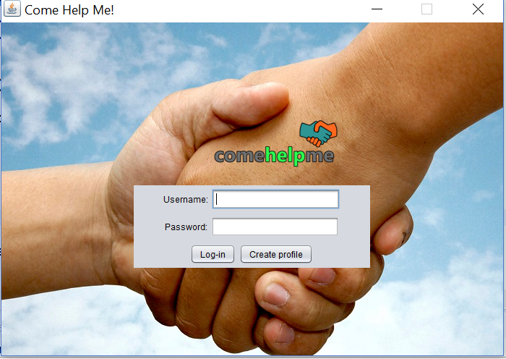

The login screen will appear.

1. Creating an Account

Click on the create profile button.

The user can select individual to create a profile for themselves or organization to create a profile on behalf of an organization.

Individuals should provide their first and last names in the provided fields; organizations will enter their name in the provided field.

Both individuals and organizations should select a username and password.

When done, click on the Sign Up button. The profile will created and the program will return to the login screen.

Click on the Return to Login button to go back to the login screen without creating a new account.

1. Logging In

Users should enter their username and password in the corresponding fields then click on the login button to access their profiles.

1. Profile Pages

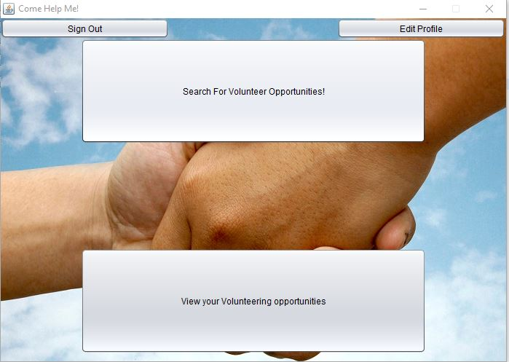

Individuals

Click on the Search for Volunteer Opportunities! button to find an event to volunteer for.

To review volunteer opportunities the user has already joined, click on the View Your Volunteering Opportunities button.

If the user would like change their login password, click on the Edit Profile button.

When done, click on the Sign Out button to the return to the login screen.

Organizations

Click on the Search for Volunteer Opportunities! button to view events in need of volunteers.

To edit volunteer opportunities the organization has created, click on the Edit Your Listings button.

The user can create new opportunities for volunteering by clicking on the Request Help! button.

If the user would like change their login password, click on the Edit Profile button.

When done, click on the Sign Out button to the return to the login screen.

1. Administrators

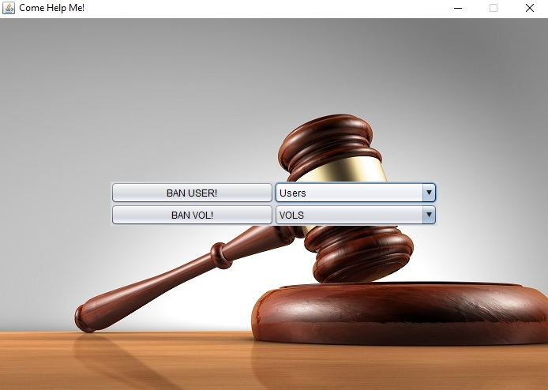

Administrators can ban users or volunteer opportunity listings.

Select a user or volunteer opportunity listing from the corresponding drop down list to ban. Then click the Ban User! or Ban VOL! button.

A dialog box will pop up. The administrator can enter the reason for the ban in the text field. Click on the Okay button to complete the ban.

If the administrator does not want to ban the user or opportunity listing selected, they can click on the Cancel button.

1. Volunteer Opportunity Listings

Organizations can create a volunteer opportunity by clicking on the Request Help! button in their profile page.

The name of the event, location, zip code, date and time should be included in the corresponding fields. The date should be inputted beginning with the day of the month. For example, January 1, 2018 becomes 01/01/2018.

There is also a field to include a brief description of the event and what volunteers are being asked to do.

Select any interests that the event relates to; this will allow volunteers to more easily find the listing when searching for volunteer opportunities to join.

When done, click on the Submit button.

Organizations can edit a volunteer opportunity listing by clicking on the Edit Your Listings button in their profile.

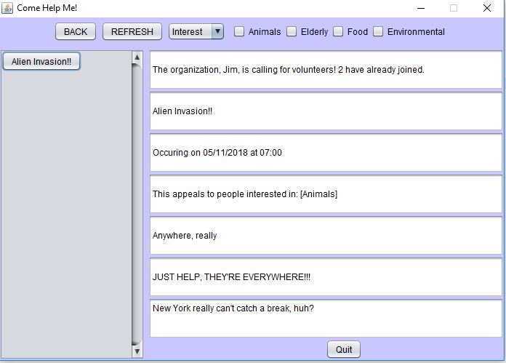

After changing the information, click the Refresh button to update the volunteer opportunity listing.

Click on the Back button to return to the previous page without make any alterations to the listing.

To return to the previous page without creating a new volunteer opportunity, click on the Back button.

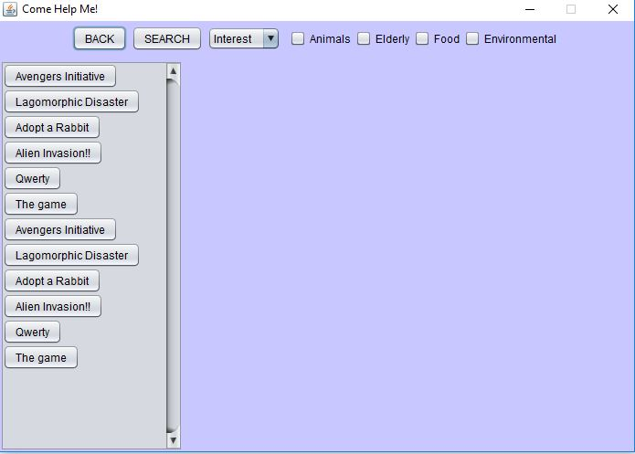

Users can search for volunteer opportunities based on particular interests, such as a desire to work with animals or the elderly, or zip code.

To search by interest, select the interest by clicking the corresponding check box. Then click the Search button. A list of volunteer opportunities fitting the search criteria will be displayed.

The listing includes the date, time, location, number of volunteers who have already joined this event and a brief description. To volunteer for this event, click on the Join button.

To return to the previous screen, click on the Back button.